David Allen

G00375372

Week 8-9

**Contains**: Assignment 5C – Pre-requisites of Sprint 2,   
Execution/Demo/Retrospective/Spike

**Team Blade Runner**:

**Scrum Master** - Ion Cirnici G00374920

**Product Owner** – Luke Byrne G00373744

**Software Engineer** – David Allen G00375372

**Software Engineer** – Sam Brownless G00260547

**Product Tester** – Ammad Aslam G00365389

Project Management



Contents

Sprint 2 - Progress/End of sprint 2

Meetings 2

Sprint backlog refinement 3

Sprint Progress 3

Spike 5

Automated Testing 5

Unit Testing 5

Acceptance Testing 6

Testing 7

Burndown chart / scrum board progress 8

User stories 8

Sprint Demo 8

Sprint Review 9

Sprint Retrospective 10

GitHub 11

Burndown chart 11

Additional Information 12

References 13

# Sprint 2 - Progress/End of sprint

## Meetings

Meetings over two weeks from sprint 2:

**Monday 2nd March – meeting**

Sprint 2 is in full swing. All planning was done on the previous Friday and each member could see the tasks available. Each member knew where to start after gaining experience from sprint 1, we were ready to perform better after learning from our mistakes.

**Wednesday 5th March – Scrum/meeting**

Members updated where they were in the current tasks. Various tasks in progress. PO advised a spike was to be introduced into sprint.

**Friday 6th March – meeting**

Halfway through sprint. Discussed what task had been completed and what needed to be done. Spike User story was complicated and realised it didn’t fit within the scope. Came to a consensus that we would remove one user story for the Spike to stay in velocity. Decided to make a plan of action so all members were on the same page and knew what task needed to be completed by the next meeting.

**Wednesday 11th March – Scrum/meeting**

Update on all members and issues that came. The website in general is moving in a good direction although issues have been raised with automated testing and all the complications it brings. All testing was to be documented and automated testing attempted.

**Thursday 12th March – meeting**

All team were rushing to be ahead of schedule. Team updated tasks. Discussed the issues with automated testing and that although automated testing would be attempted, it wouldn’t give us the desired results. Only testing left to be completed.

**Thursday 12th March – Sprint review/demo**

CORID-19 is causing issues all around the world. Facilities would be closed from 6pm onwards for safety precautions. Team got together to complete review and sprint as it would be the last time all members are together.

## Sprint backlog refinement

All user stories were investigated to make sure they were broken down into appropriate smaller tasks and were prioritized to ensure all would be completed in order of importance.

Halfway through the sprint the PO introduced a new user story called a spike, which was prioritized as urgent. All members reviewed our velocity and agreed it was not within our scope but needed to be brought into the current sprint. We agreed that a current user story had to be removed so that it can be fitted in. Our review user story was removed to include the Spike. The sprint continued with an updated backlog.

## Sprint Progress

A short and brief explanation of the sprint progress. A more detailed version is available on OneNote. All user stories taken from the product Backlog to create the sprint plan.

Originally six user stories were broken up into tasks for Sprint 2. But with one

Task not being fully completed in sprint 1, it was moved into sprint 2. To start with, tasks have initially been picked by members to work on.

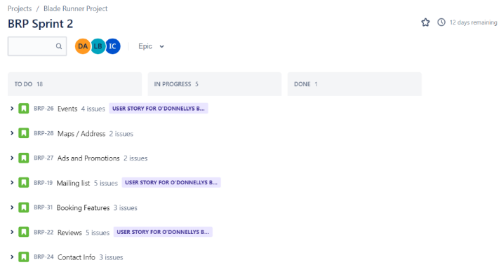 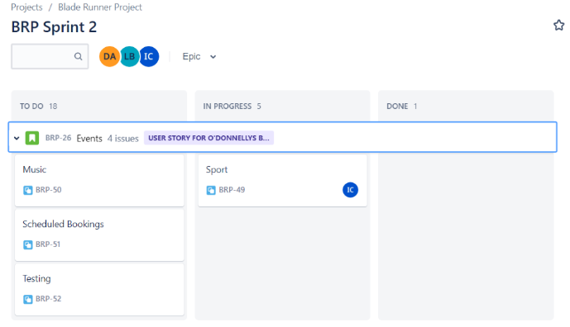

As seen in the image below. A Spike user story was to be added to the Sprint into the second week. It was an urgent request from the product owner that required priority over other user stories. But to make room for the task, we had to take away the review user story to keep our velocity. The review task was moved into the backlog for future releases.

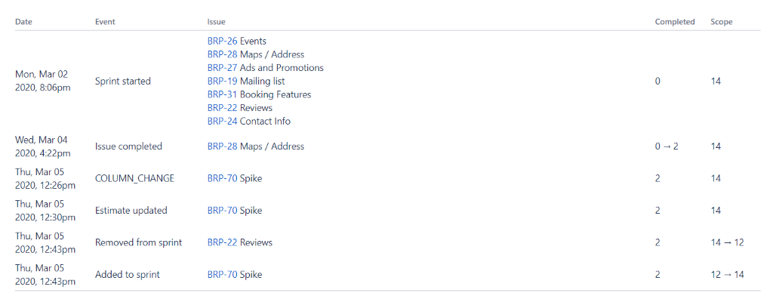

You can see the sprint started with seven tasks but there was a change when the spike was introduced. As a result one user story was removed from the sprint.

As the sprint continued, tasks were slowly completed and members moved on to other tasks one by one. Eventually as we approched the end of the sprint, all tasks were moved to done.

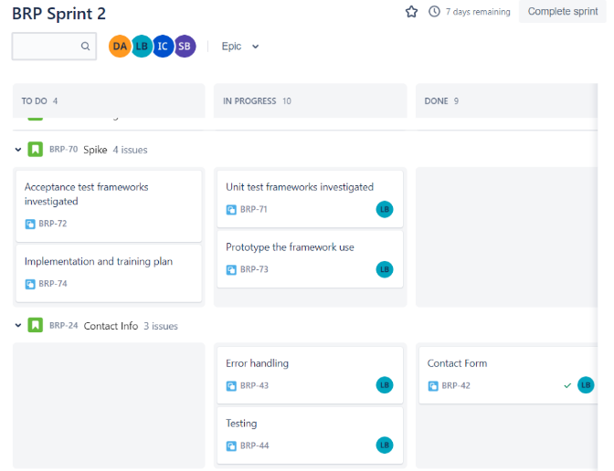 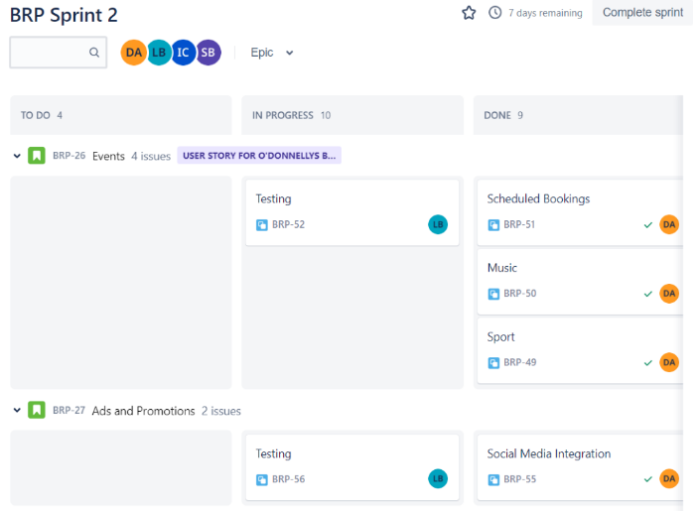

Finally Sprint 2 was completed. It had its up and downs. There was issues along the way and with the introduction/removal of tasks as sprint progressed, caused complications. Although it enabled the team to adapt and raise to the occasion, providing the product owner with what they required.

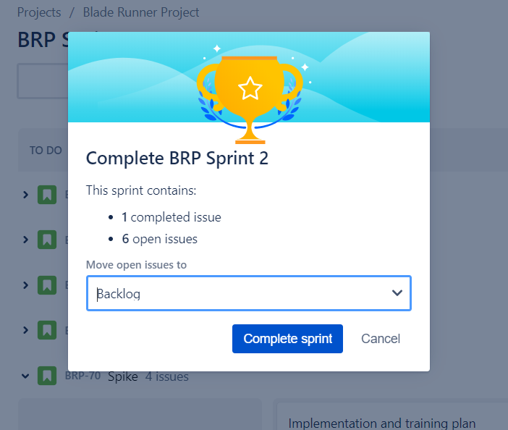

Small error in using Jira. Sprint 2 was completed and as shown in the images below, progression of the second sprint was steady. But even though the task were completed, the sprint shows 6 open issues. These issues are that even though the tasks were moved to be completed/done, their was another option to actually complete the task that wasn’t done, meaning that even though the tasks were completed, they weren’t finished on Jira, meaning the data is skewed and doesn’t show the true data of the sprint.

## Spike

During our second sprint a spike was implemented by the product owner, the goal of this spike was to investigate automated testing for the project. Our tester researched automated testing and found selenium to be the most appropriate for our project and set to work on investigating implementing the framework. The tester found useful resources in the form of tutorials which were rolled out to the development team unfortunately within the limited timeframe of two weeks the team did not manage to develop any automated tests with the framework and so carried out manual testing for the sprint.

The sprint was handled by the team reasonably well in that the framework for automated testing was investigated and could potentially be implemented in further releases.

### Automated Testing

As mentioned in the section on the spike the automated testing was investigated and tutorials were rolled out to the team however due to the limited number of elements to test and time restrictions within the two weeks the team did not manage to develop any automated tests but instead carried out manual tests.

The automated testing caused a lot more issues than we thought. We knew adding the spike halfway through Sprint 2 would cause issue, but we were not prepared for the difficulty that would prevail. The tester thoroughly researched into automated testing and it was found that Selenium, an open source automation testing framework was the best course of action. On initial inspection it seemed perfect for what we needed. Yet as our tester moved into starting tests, the problem of each test needing to be coded for its individual use became apparent. Our knowledge was not up to code with all the details needed and we couldn’t move forward. Our tester reached out to professionals within the field and it discovered that the best use of Selenium was done with the Python language. Unfortunately, none of our team know this language and there was not enough time to develop the skill.

Our skills would not provide test results through automated testing. It was a lot more difficult than we thought and only caused headaches and delays. Either way the user story was not fully completed. The last task was implementation and training plans of automated testing and it was not completed to our definition of done. An initial training plan was investigated, with Selenium tutorials being sent out for members to familiarise themselves with, but it wasn’t fully implemented as we couldn’t figure out all the kinks in writing the tests ourselves. It was put on the back burner and our tester used test cases to execute the testing.

### Unit Testing

In general Unit testing uses an automated testing framework, but due to the team’s lack of knowledge, we focused on test cases.

For the unit testing we divided each element of the project into separate cases and created test cases they were then ran through manually and the test results were recorded.

### Acceptance Testing

For our acceptance testing we focused on user acceptance testing. We focused on the user, as they will be the people using the website and who it is designed for. We created a questionnaire as a framework that put the areas we wanted looked at in the spotlight.

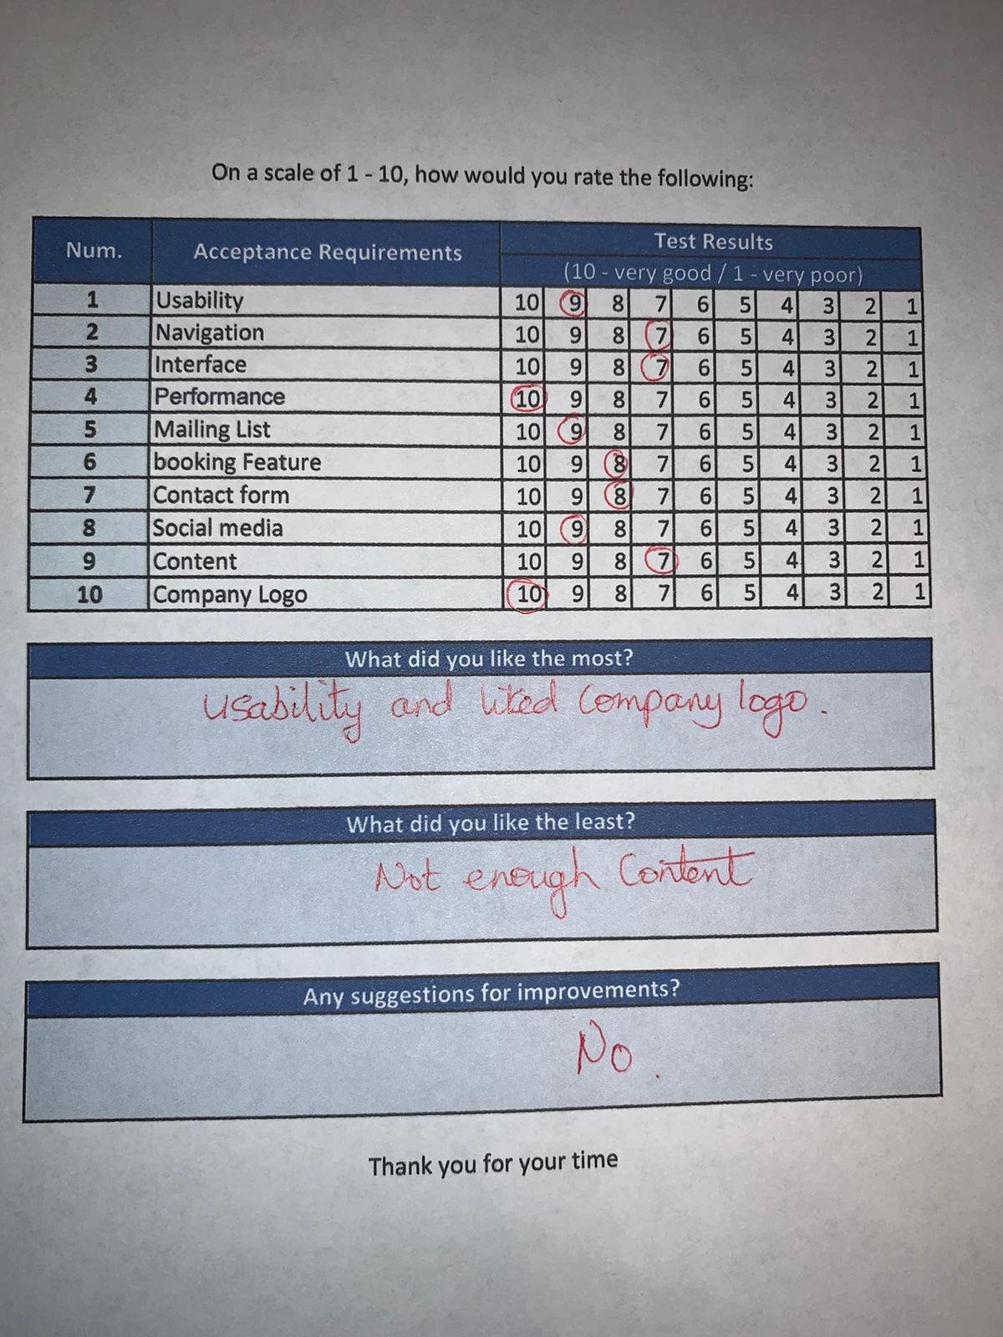 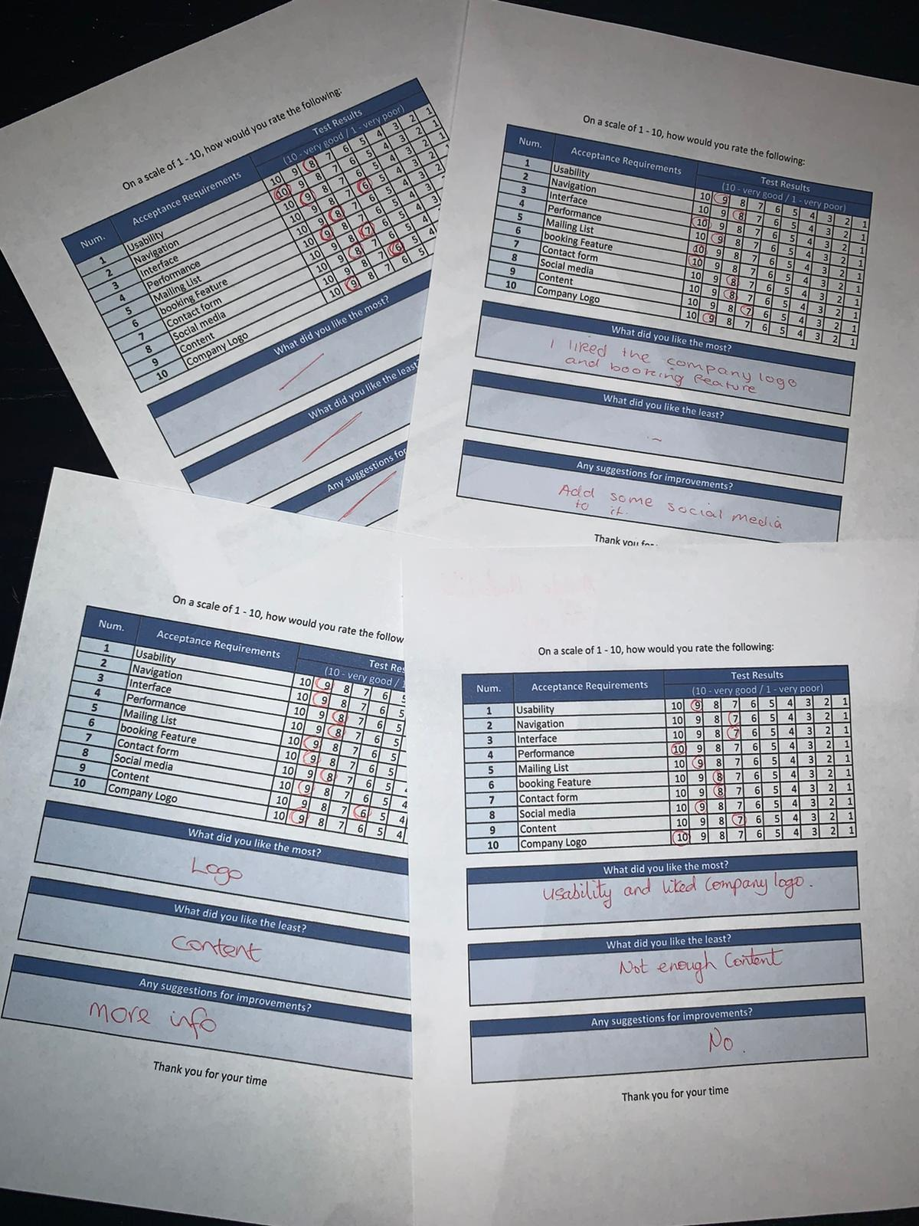

For our acceptance testing we brought in 4 unbiased outside parties of various age and gender, to separately use and give opinions on the product the overall result of which was positive with none of the users having any issues with navigation or usability.

|  |  |  |  |  |  |  |  |  |  |  |  |
| --- | --- | --- | --- | --- | --- | --- | --- | --- | --- | --- | --- |
| **Num.** | **Acceptance Requirements** | **Average Test Results** | | | | | | | | | |
| PASS | | | | | **FAIL** | | | | |
| **1** | Usability | 10 | 9 | 8 | 7 | 6 | 5 | 4 | 3 | 2 | 1 |
| **2** | Navigation | 10 | 9 | 8 | 7 | 6 | 5 | 4 | 3 | 2 | 1 |
| **3** | Interface | 10 | 9 | 8 | 7 | 6 | 5 | 4 | 3 | 2 | 1 |
| **4** | Performance | 10 | 9 | 8 | 7 | 6 | 5 | 4 | 3 | 2 | 1 |
| **5** | Mailing List | 10 | 9 | 8 | 7 | 6 | 5 | 4 | 3 | 2 | 1 |
| **6** | booking Feature | 10 | 9 | 8 | 7 | 6 | 5 | 4 | 3 | 2 | 1 |
| **7** | Contact form | 10 | 9 | 8 | 7 | 6 | 5 | 4 | 3 | 2 | 1 |
| **8** | Social media | 10 | 9 | 8 | 7 | 6 | 5 | 4 | 3 | 2 | 1 |
| **9** | Content | 10 | 9 | 8 | 7 | 6 | 5 | 4 | 3 | 2 | 1 |
| **10** | Company Logo | 10 | 9 | 8 | 7 | 6 | 5 | 4 | 3 | 2 | 1 |

Looking over the results, everything passed, and nothing failed. Although looking over the data and comments left, the biggest concern was the content and that it could be improved. This was passed onto the product owner and can be revised into future updates.

### Testing

Test case were put together by our tester to replace automated testing. Test cases record the test data, the expected results, the actual result, the status and any notes relevant to the test. It was the best option available when automated testing proved too time consuming and outside our expertise.

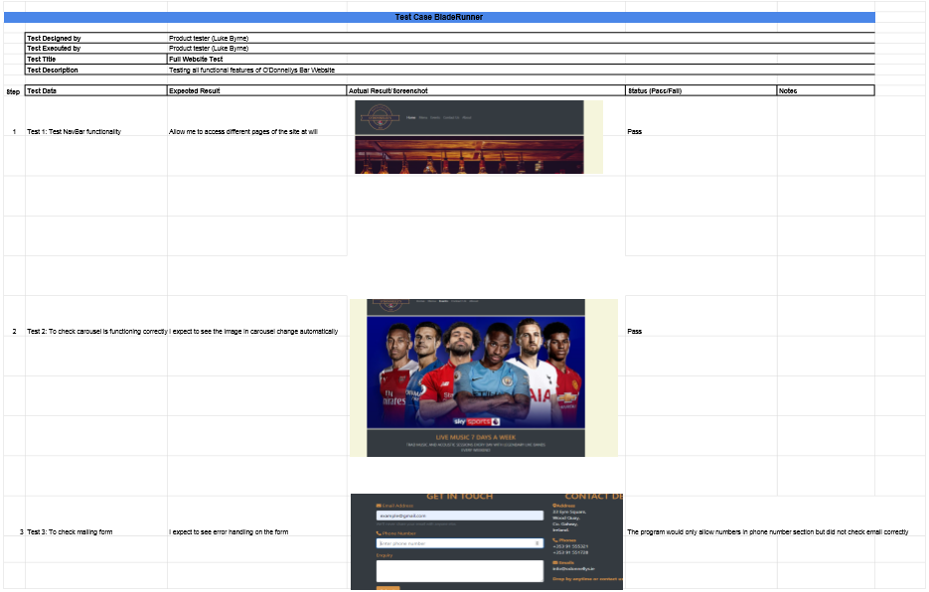

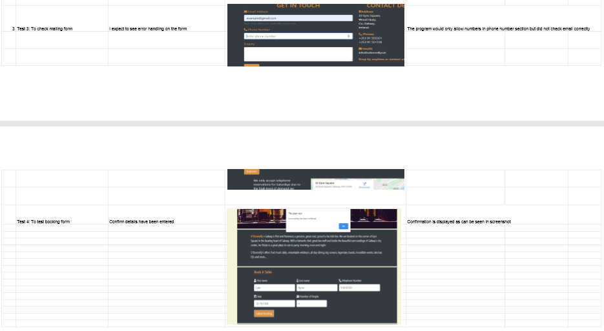

The product owner decided that we should implement automated testing as part of what is known as a spike this meant that the PO had to decide which of the user stories to remove from the sprints backlog, after a meeting with the rest of the development team it was agreed and decided that the review section would be the most problematic user story and that it was a reasonable opportunity cost for the spike and so it was removed from the backlog.

After researching online on forums such as stackoverflow that the most appropriate framework to use for the automated testing would be selenium. The product tester commenced further research on the framework and found many useful resources on how to use it. This was rolled out to the team as part of the investigation.

Unfortunately due to the complexity of the framework and the time constraints on the team in the two week period on top of the issue around there not being a substantial enough amount of software to use automated testing it was agreed by the team that it would be passed on to potential future releases.

## Burndown chart / scrum board progress

Full comprehensive documentation for all sprints on OneNote / GitHub.

## User stories

All user stories were completed apart from one unfortunately. The Spike being added to the sprint halfway through caused some issues and one task was unable to be completed to a good standard. For stage by stage updates, please refer to the OneNote documentation.

## Sprint Demo

Sprint 2 demo has been uploaded and can be accessed from GitHub. YouTube version available on link: <https://www.youtube.com/watch?v=eBwi7h05d3Y>

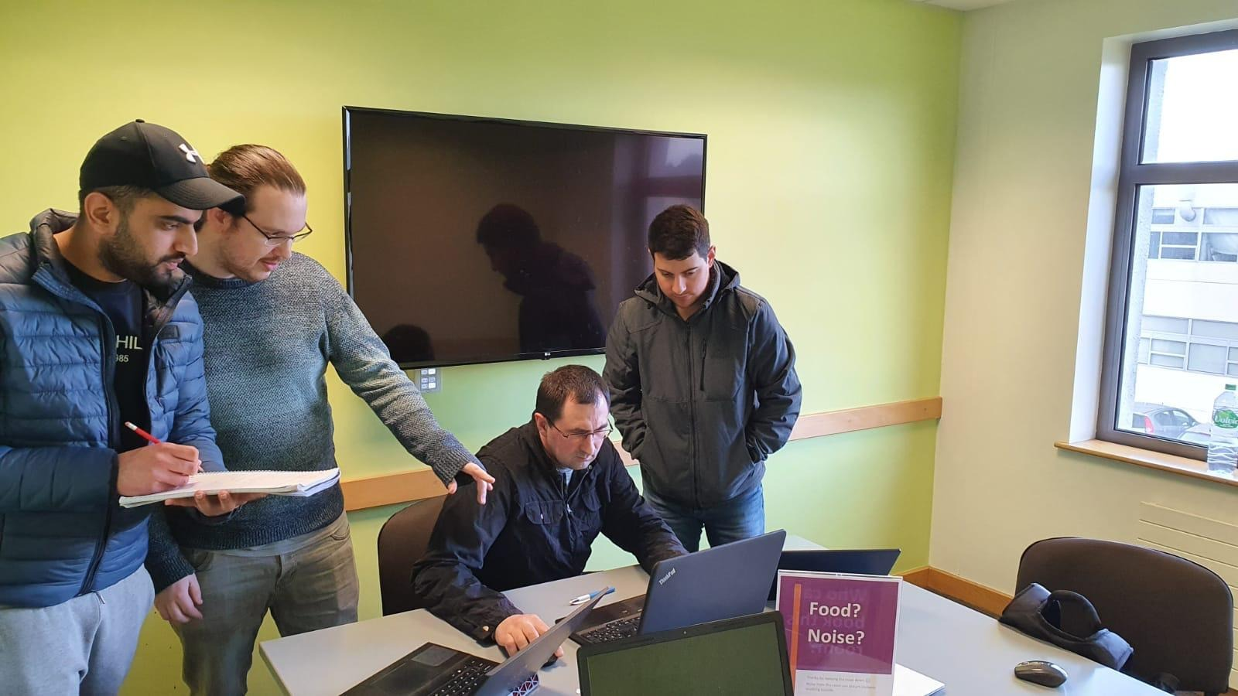

## Sprint Review

The sprint went relatively well. We had our ups and downs, it didn’t help that the product owner introduced a spike, which meant we had to remove one user story to fulfil the requirements of the product owner. The team was able to adapt to the situation well, meaning the velocity was not affected. Although a spike was a huge demand on the team and asked for automated tests to be completed. The team had issues with automated testing and ended up running test cases to finish the tasks. This had an ongoing effect and the team was not able to complete all tasks to the definition of done. Automated testing was meant to be implemented and a training plan produced. All members have access for training with the new Selenium automated testing framework, but it was unable to be implemented due to the difficulties all members had. Unfortunately, full automation testing would have to be implemented in a future release.

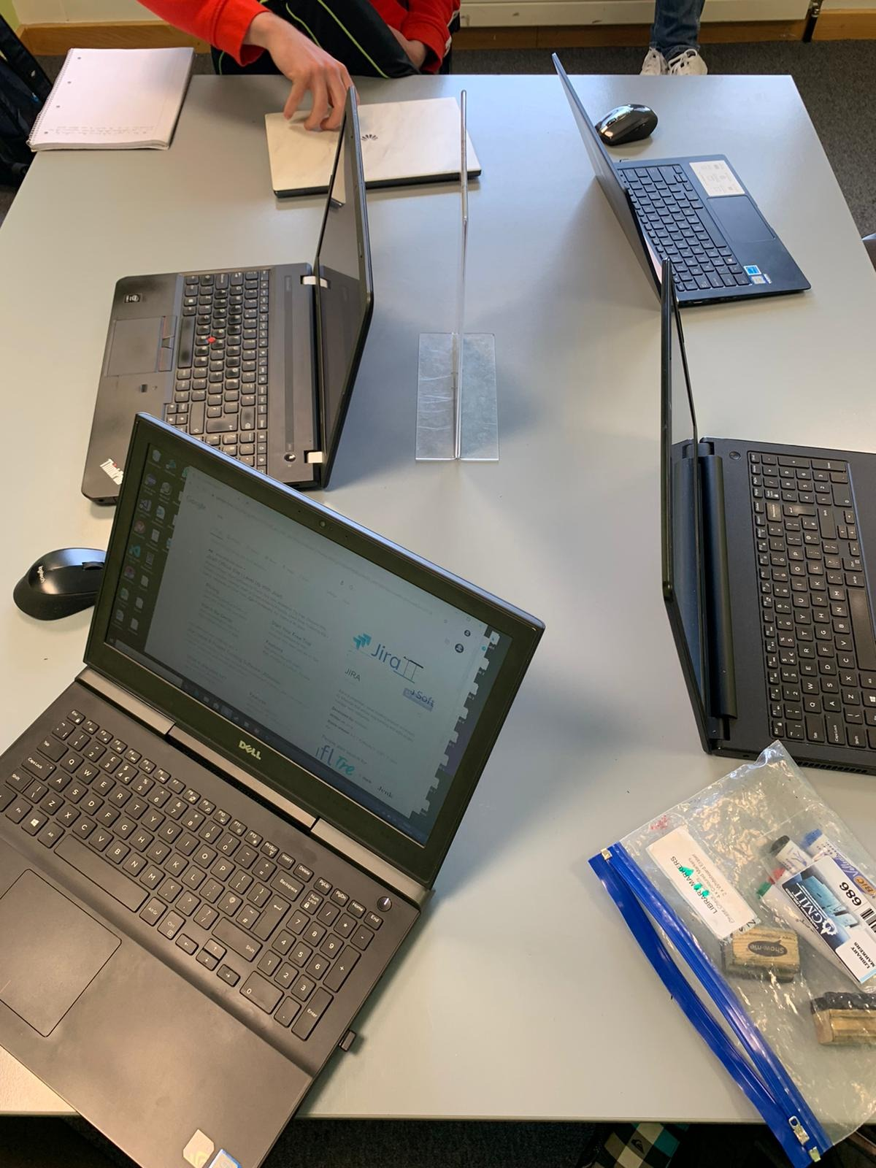

A consensus was made, and all members agreed that sprint two had worked better than sprint one. More than likely due to each member having learnt from their mistakes from sprint one and improving on previous issues.

Sprint two wasn’t with out its issues but the team were learning and adapting to all requirements. All members recognised that through the experience of each sprint the process would become more streamlined and would only improve efficiency for future releases.

CORID-19 was an unexpected occurrence, but the team had been monitoring the situation and were aware the work premises would close. So Additional hours were put in to get ahead of schedule and finish the sprint within scope.

## Sprint Retrospective

On the final day of the sprint the entire team had a meeting and discussed the results of the projects second sprint. The consensus was overwhelmingly positive with all team members satisfied with how the team performed with the inclusion of a spike, demonstrating flexibility and adaptiveness amongst the team. It was unfortunate that automated testing could not be implemented but manual testing would be enough.

During the meeting an anonymous vote was held just in case certain members had something they would rather mention anonymously fortunately all the feedback was positive and it was agreed that the sprint was overall a success.

The team aimed to improve on the automated testing in the next Sprint should there be any further releases.

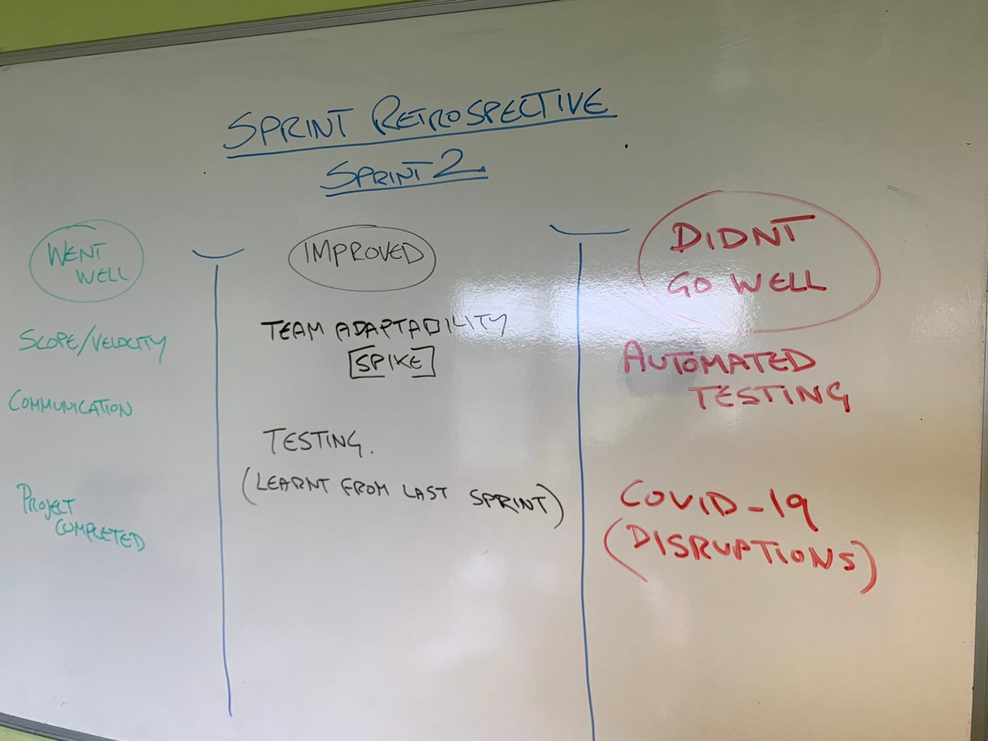

All members remained impartial about the work. Any comments were put down on post it notes, and the scrum master read them out, so no member would be judged, and all opinion were valid.

## GitHub

GitHub is steadily updated by each member. A baseline was made at the beginning of sprint 2, so we had a fall-back point with the code done so far. Majority of the information is uploaded to GitHub, including all artifacts. But for all comprehensive documentation, it is stored on OneNote, which is also available through GitHub.

## Burndown chart

Burndown charts were documented every couple of days starting on day one. Leading onto the end of week one. You could see a slight change were the tasks were making some progress but were still being worked on.

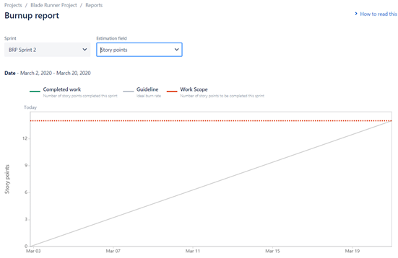 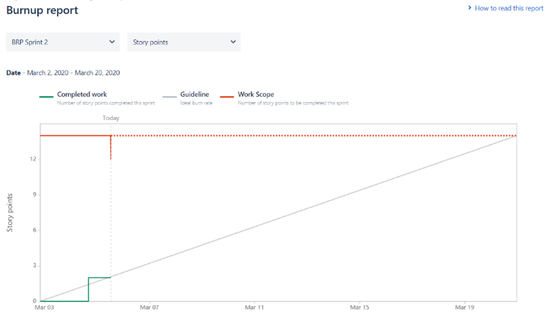

The final burndown chart was made at the end of the sprint. Although we could see there was something wrong. The data was available on Jira and was updated to done, yet the chart did not show the progression.

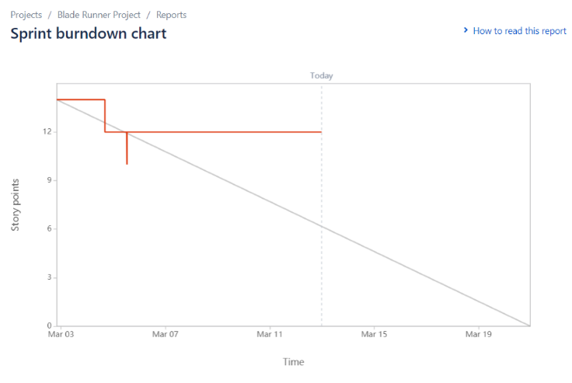

Burndown chart causing issues again. Although we thought we had resolved all issues, another one comes along. Even though majority of the tasks had been flagged as complete/done. It appears that there was an additional section that needed to be filled out to prove the task was done.

Here was a hand drawn version of what the burndown chart should have looked like at the end of sprint two.

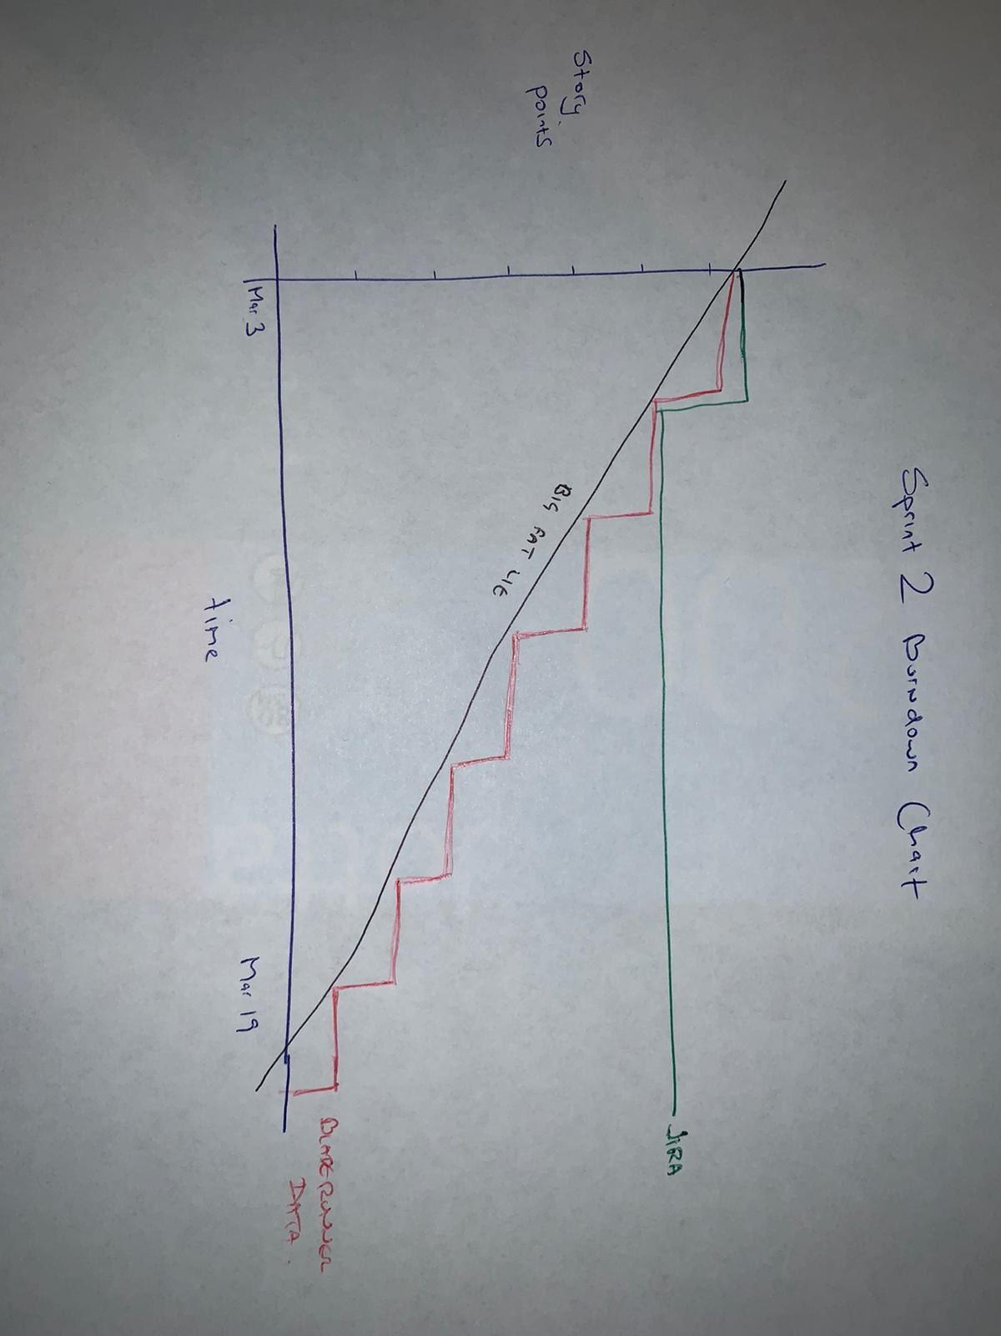

Problem explained/documented thoroughly on OneNote.

## Additional Information

As part of the agile experience, all members wanted to make the most of the situation. So, to reference the pig and the chicken scenario, we had another student Emil Parvanov be present during one of our meetings / scrums.

It was strange having another team’s member be part of our meeting, but at the end of the day they had no real input and were only there to observe. All members seemed to act more professional, as additional eyes were watching.

## References

**Automated Testing**

YouTube. 2019. *Selenium Tutorial For Beginners*. [online] Available at: <https://www.youtube.com/watch?v=Jdkrj2lDAEY&feature=youtu.be> [Accessed 16 March 2020].

**Selenium**

Huggins, J., 2020. *What Is Selenium? Introduction To Selenium Automation Testing*. [online] Guru99.com. Available at: <https://www.guru99.com/introduction-to-selenium.html> [Accessed 17 March 2020].

**Acceptance testing**

Setter, M., 2020. *User Acceptance Tests*. [online] Usersnap.com. Available at: <https://usersnap.com/blog/user-acceptance-testing-right/> [Accessed 18 March 2020].

Random issues

<https://stackoverflow.com/>

was viewed on occasion to get information on various areas of confusion

For developers, by developers